**Sukuna Multiple Campus**

**Tribhuvan University**

**A Final year Internship Report**

**On**

**Web Development**

**At**

**Charicha Institute**

**Submitted to**

Office of the dean,

Faculty of Education

Tribhuvan University

**In partial fulfilment of the requirement for the**

**Degree of**

**Bachelor Information and communication Technology (BICT)**

**Submitted by**

Raj Narayan Mehta

Roll no.: 73214019

TU Reg. no. : 9-2-214-176-2016

August 2022

**RECOMMENDATION**

I here by recommend that the internship report prepared under my supervision by **Mr. Raj Narayan Mehta** entitled “**E-Commerce”** accepted as fulfilling in partial requirements for the degree of Bachelor of Education in Information Communication and Technology(ICT). In my best knowledge this is an original work and is forwarded for the further evaluation.

___________________________ ______________________

Atul Bhattarai Shyam sedhai

**Sukuna Multiple Campus, Morang** **Balkumari College, Chitwan** **External Supervisor** **External Supervisor**

**Letter of Approval**

The undersigned certify that they have read and recommended to the Department of Education (BICT) for acceptance, an internship report entitled “internship Report on Web Developing at Charicha Institute.” Submitted by **Mr. Raj Narayan Mehta** in partial fulfilment for the degree of Bachelors of Information and Communication Technology Education. This ensures that is satisfactory in the scope and quality of the required degree.



**ABSTRACT**

The internship at Charicha Institute was completed as a requirement for partial fulfilment of BICT degree at Tribhuvan University. The internship was for the period of three months. During this period we were exposed to gain practical knowledge about different programming languages.

In the training I got the chance to convey my theoretical knowledge into practical knowledge and skills. We learnt how the single website or application is developed by company. This internship gave me an opportunity to observe closely how this software development company operates and also gain additional practical knowledge of operation of newly emerge tools and technologies in the IT industry.

The key to having successful and fully functional web applications is in their communication with the user. It is of no surprise that human/machine interaction is a popular topic of research and development, as is the main goal at the research Centre for Information Technologies, where I had the honours to spend my first training period. A solution has been proposed for the internationalization and customization of web applications in general. Taking into account web standards and the back-end and front-end architecture of web development, a method for providing a multi-language web interface has been planned from scratch and explained in details in this report.

**Weekly Table**

|  |  |  |  |
| --- | --- | --- | --- |
| **Week** | **Working department** | **Major works** | **Approved by** |
| 1st | Web Development | Learned basic HTML and CSS from w3schools,  [CSS-Tricks](https://css-tricks.com/) | Sagar Adhakari |
| 2nd | Web Development | Learned basic HTML and CSS from w3schools,  [CSS-Tricks](https://css-tricks.com/) | Sagar Adhakari |
| 3rd | Web Development | Project setup for webpage using GIT and gulp | Sagar Adhakari |
| 4th | Web Development | Learned basic JavaScript from W3schools. | Sagar Adhakari |
| 5th | Web Development | Learned basic JavaScript from W3schools. | Sagar Adhakari |
| 6th | Web Development | Created basic webpage template using HTML,CSS, JavaScript, gulp, GIT | Sagar Adhakari |
| 7th | Web Development | Learned and implemented the code from slider and animations for project using JavaScript and CSS | Sagar Adhakari |
| 8th | Web Development | Created the responsive design for project(E-commerce ) | Sagar Adhakari |
| 9th | Web Development | Created the responsive design for project(E-commerce ) | Sagar Adhakari |
| 10th | Web Development | Completed the front page design | Sagar Adhakari |

**ACKNOWLEDGEMENT**

At first, I would like to express my sincere gratitude to **Sukuna Multiple Campus**, department of Education for providing me an opportunity to conduct this internship.

I would also like to gratitude express my special to Bikram Shrestha Managing director of **Charicha Institute** for providing me the opportunity to at conduct my internship this reputed organization with full support and cooperation.

I would also like to express my heartfelt gratitude to Sagar Adhikari**,** Full-stack developer, who has given me a proper guidance during internship. I am so thankful to him as by following his guidance, I was able to cope with many programming skills in short period of time.

Last but not the least, my sincere thanks goes to friends, family members and classmates for their direct or indirect continuous support co-operation.

**LISTS OF FIGURES**

Figure 3 1: home page. 8

Figure 3 2: Login 9

Figure 3 3: Registration 10

Figure 3 4: Shopping cart 11

**TABLE OF CONTENTS**

CHAPTER I 1

1 INTRODUCTION 1

1.1 Background 1

1.2 Objective of Internship 2

1.3 Selection of Organization 3

CHAPTER II 4

2 INTRODUCTION OF THE COMPANY 4

2.1 Context 4

2.2 Major functions of organization 4

2.3 Introduction of department 5

2.4 Present situation 5

CHAPTER III 6

3 ACTIVITIES DONE 6

3.1 Customer communication 6

3.2 Discussion 6

3.3 Peer/group Review 6

3.4 Conflict and its managements 6

3.5 System analysis 7

3.5.1 Functional Requirements 7

3.5.2 Non-functional Requirements 8

3.6 Design 8

3.6.1 Specification design 8

CHAPTER IV 12

4 AN ASSESSMENT OF THE INTERNSHIP 12

4.1 Learn from the Internship 12

4.2 Applied Theory Knowledge into Practicum 13

4.3 Challenges 13

CHAPTER V 14

5 CONCLUSION 14

REFERENCES 15

# CHAPTER I

# INTRODUCTION

## Background

As per the requirement of the Tribhuvan University for the B.Ed. ICT final semester students are required to complete a six credit (minimum ten weeks/ 180 hour long) internship as a part of the course requirement.

Internship opportunity provides the students a great chance to relate their theoretical knowledge with the competitive and tough real job market environment.

Internship are formal programs designed to provide practical experience in real world environment to students who are new to that field. There is no standardized duration for how long an Internship program lasts but typically an Internship is the period of three to twelve months. During this period, interns have the opportunity to explore their field of interest, find out what future they are diving into and whether or not their skill sets match their path of career.

Industry is a crucial requirement of the internship course and this will have to be secured before getting started with the course. The internship in specialized field provides students in-depth understanding about field, market exposure, and help to identify the potential career opportunities. Internship project is good for students to understand real world implications of the sound academic knowledge gained in college.

An internship is a professional learning experience that offers meaningful, practical work related to a student’s field of study or career interest. An internship gives a student the opportunity for career exploration and development, and to learn new skills. It offers the employer the opportunity to bring new ideas and energy into the workplace, develop talent and potentially build a pipeline for future full-time employees.

E-commerce is the buying and selling of goods or services via the internet, and the transfer of money and data to complete the sales. Author used the technologies as HTML, CSS, java script and bootstrap. Any user can accessed without any barriers direct log in and registration and bought anything available in this site.

## Objective of Internship

This internship report is undertaken for the partial fulfilment of the requirements for the degree of Bachelor in Information communication and technology. The report is prepared for the purpose of acquainting the achievement of during the internship. The following are the internship objectives that were to be achieved:

1. To reduce the gap between the academic and industry.
2. To be able to work in the future after the completion of academic degree.
3. To learn to maintain interpersonal and intrapersonal skills.
4. To be able to maintain good public relationship.
5. To implement the theoretical knowledge into a practical approach.
6. To be able to learn the actual functioning of an organization
7. To develop skills in the application of theory to practical work situations.
8. To test the attitude for a particular career.
9. To develop skills and techniques directly applicable to the careers.
10. To know the coding style and conventions of the industry.
11. To go through the development cycle and models.
12. Retaining More Visitors

As per statistics, websites and apps which lack good front-end design will diminish visitor interest making it unlikely for them to return. On the other hand, skillfully designed frontends make visitors stay on the website. Also, it is more likely to have increased traffic as well as customer conversions.

1. Making a Good First Impression

Most visitors spend only a few seconds deciding whether to stay on a particular site or switch to some other site. The front end serves as the first look of a company. Hence investing in front-end development makes business sense.

1. Effective Branding

The front-end serves as a tool to market your organization. It inspires trust as well as confidence in prospective clients. A visually attractive and well-organized GUI makes for an effective advertisement for your brand.

1. Offer Ease of Use

Today’s customers prefer user-friendly sites. The front end should be simple and convenient to use. Also, the navigation needs to be intuitive and seamless. The GUI should not be cluttered and offer a superior User Experience.

1. Responsive Design

Currently, there is a vast variety of hardware and operating systems. This trend is likely to persist in the future. The front end should be compatible with any kind of device or operating system.

1. Fast load time

Most users don’t have patience with sluggish websites. The front-end should load quickly and deliver the fast and efficient response to user actions.

## Selection of Organization

For any commercial websites or apps, a front end developer is needed for any application because that matters more. On the other side, web development, maintenance, web design front end developer skills are some of the most excited and most in-demand skills now. Nowadays many more large companies are demanding front end developers, mainly start-ups. For front end developers, this led to the more increase in demand.

The selection of an organization is the most important and crucial decision part of internship program. Organization which allows to work under the supervisor who will provide directions, monitor duties and spend time mentoring would be excellent. A successful internship experience is an appropriate organization provides awareness of specific needs and understanding of the options available. Selection of proper organization will help to work with interest and learning strength.

# CHAPTER II

# INTRODUCTION OF THE COMPANY

## Context

Charicha Institute is located in Belbari-11 Laxmimarga, sumnima chowk Morang. Charicha Institute is a foremost Development & Design expert company. Skilled intellectual personnel, most having substantial work experience in diverse areas of Information Technology make up our team. Our management guarantees that each individual excels in their specific assigned tasks by working closely with them. Only those individuals are hired who not only possess strong technical and analytical skills, high intellect, sound work ethics and integrity but also who have confidence, decision making abilities and above all the drive to excel whether it is at the management level or at a technology software development position.

Our focused, sound and innovative methodology is derived from the collective experience of our team members and as a result of their combined practical business experience with strong technology delivery capabilities, we are able to understand the Client business requirements, propose IT and Creative strategies in line with the vision of the business and execute the business plan by building or implementing high quality scalable business solutions through the use of latest cutting edge Technologies. Our goal is to surpass our customer's beliefs in the form of value, quality and comprehensive customer satisfaction.

## Major functions of organization

In Charicha Institute they believed on the quality of work, experience and knowledge enable us to deliver tailored and professional solutions for clients. Following tasks done Charicha Institute.

1. Web designing
2. Software developments
3. Mobile app development
4. Digital marketing
5. Hardware and networking
6. Web hosting and domain registration

## Introduction of department

Bachelor of Education in Information Communication Technology (BEd ICT) is an undergraduate program offered by Tribhuvan University, under the Faculty of Education. It is a 4.5-year semester-based program spreading over 9 semesters covering a total of 141 credit hours, that includes 12 credit hours for communication skills courses, 24 credit hours for educational core courses, 62 credit hours for specialization major subjects, 30 credit hours for minor subjects and 9 credit hours for teaching internship/practicum.

## Present situation

Charicha Institute are newly created companies that aspire to grow under extreme uncertainty. Charicha Institute, which is a key driver in creating new businesses and jobs. The environment of software Charicha Institute is extremely dynamic, unpredictable, and chaotic. Despite good early achievements, over time and during scaling up, software development and organizational management increase in complexity causing deterioration of performance over time. And this creates a scope for researchers to work on the reasons behind the failures or success of Charicha Institute. Generally, Charicha companies develop software on an ad-hoc basis and most of the time, with very limited resources and less experienced people in the team. So there are no specified practices/methodologies being followed. There are several kinds of research of software development methodologies but very few researches covered the dynamic and uncertain development method of Charicha Institute. From a software engineering perspective, Charicha Institute are dynamic and have uncertain situations where they develop software in a context where processes can hardly follow any prescriptive methodology. Characteristics of Charicha Institute companies are not similar to established and regular business companies that’s why they have different workflows.

# CHAPTER III

# ACTIVITIES DONE

## Customer communication

In considering "communication" we are referring to all means mechanisms of communicating information both within the company, Group and externally to existing and potential customers, regulators, share owner, government and non-governmental communication media such as, press, Email, and social media.

1. Communicating in a simple manner to understand better what is required of us.
2. Talk it out openly with the necessary person to make the best of use our limited time, avoid confusions and eliminate unnecessary detours.
3. Keeping communication casual yet respectful.

## Discussion

At first, we were divided in a group of three member where we were asked a design a blueprint of the project that was given to us. We decided to split up the task to each individual on the supervision of our mentor. We did a lot of group or individual conversation with our mentor and peers to enhance the practical knowledge gained throughout the internship. This enabled the work spirit and trust in our team.

## Peer/group Review

Now, after finishing the individual work assigned to us, we were asked to take review to our peer's work. It helped us to find out the errors and improvised in a better way. Eventually, our inspection skills and analysing skills were boosted which is essential for anyone in the future.

## Conflict and its managements

During the process of analysing others or peer's work, a serious disagreement or argument was introduced. As everyone's opinion did not match with others, they started to argue with the fact that they thought was right according to them. It was handled by us and our mentor with good reasons and last the dispute was handled in a great way. This situation developed a skilled of dispute management among us and it also taught us to tackle the type of condition that may show up in our forthcoming days.

## System analysis

System Analysis encompasses those tasks that go into determining the needs or conditions to meet for a new or altered product, taking account of the possibly conflicting requirements of the various stakeholders, such as beneficiaries or users.

System analysis is critical to the success of a development project. Requirements must be actionable, measurable, testable, related to identified business needs or opportunities, and defined to a level of detail sufficient for system design.

The end-user’s requirements should be determined and documented, what their expectations are for the system, and how it will perform. A feasibility study will be made for the project as well, involving determining whether it’s organizationally, economically, socially, technologically feasible. It’s very important to maintain strong communication level, with the clients to make sure we have a clear vision of the finished product and its function.

It consists of defining the problem, identifying its cause, specifying the solution and the information requirements that must be met by a system solution. The main goal of this phase is to clearly gather customer requirements, avoid ambiguities and finalize the project scope.

### Functional Requirements

Functional requirements explain what has to be done by identifying the necessary task, Action or activity that must be accomplished. Functional requirements analysis will be used as the top-level functions for functional analysis. It defines a function of the system or its components. It deals with what the system should do. It includes the description of the required functions, outlines of associated reports or online queries, and details of data to be held in a system. It includes functions performed by specific screens, outlines of work-flows performed by the system, and other business or compliance requirements the system must meet.

### Non-functional Requirements

Non-functional requirements are requirements that specify criteria that can be used to judge the operation of a system, rather than specific behaviours. These requirements that are not directly concerned with the specified function delivered by the system. They describe how, how well or to what standard a function should be provided. Non-functional requirements may describe aspects of the system that don't relate to its execution, but rather to its evolution over time (e.g. maintainability, extensibility, documentation, etc.).

## Design

### Specification design

**Home page**: The first web page that is displayed usually containing links hyperlinks to the other pages of the site. Here is the home page of the e-commerce and it established credibility and tells potential customers what my e-commerce website sells and always entice visitor to stay and explain the product 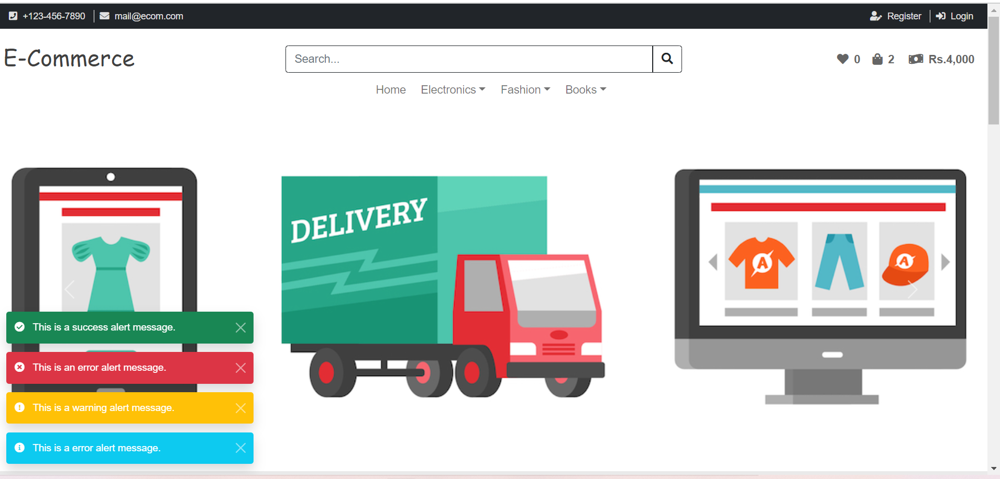

Figure 3 1: home page**Login:** The login form is simple username and password form that lets users with an existing account log into the site.

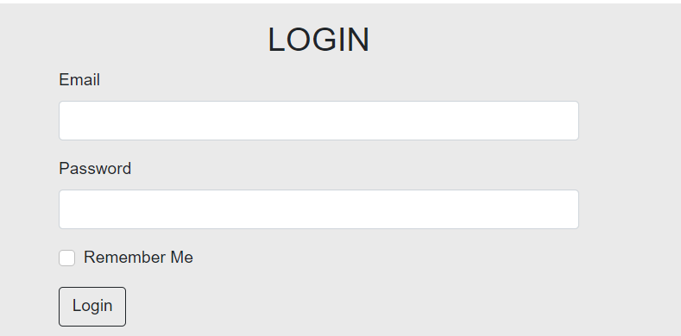

Figure 3 2: Login

**Registration:** The ultimate goal of planning registration in to collect as many registration as possible. Registration users may be granted privileges beyond those granted to unregistered users.

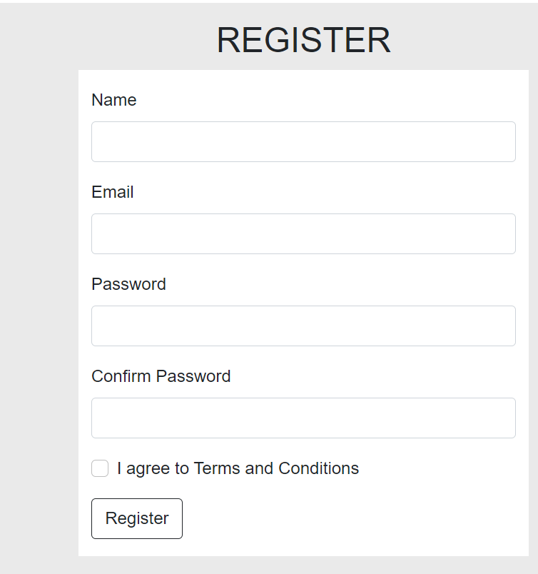

Figure 3 3: Registration

**Shopping cart:** This maintains a clean and organized record of the transaction that takes place, so as to prevent any sort of confusion helping in efficient management of the customers during peak hours. Automatically billing, payments option and the ability to change quantities are the vital features of shopping cart.

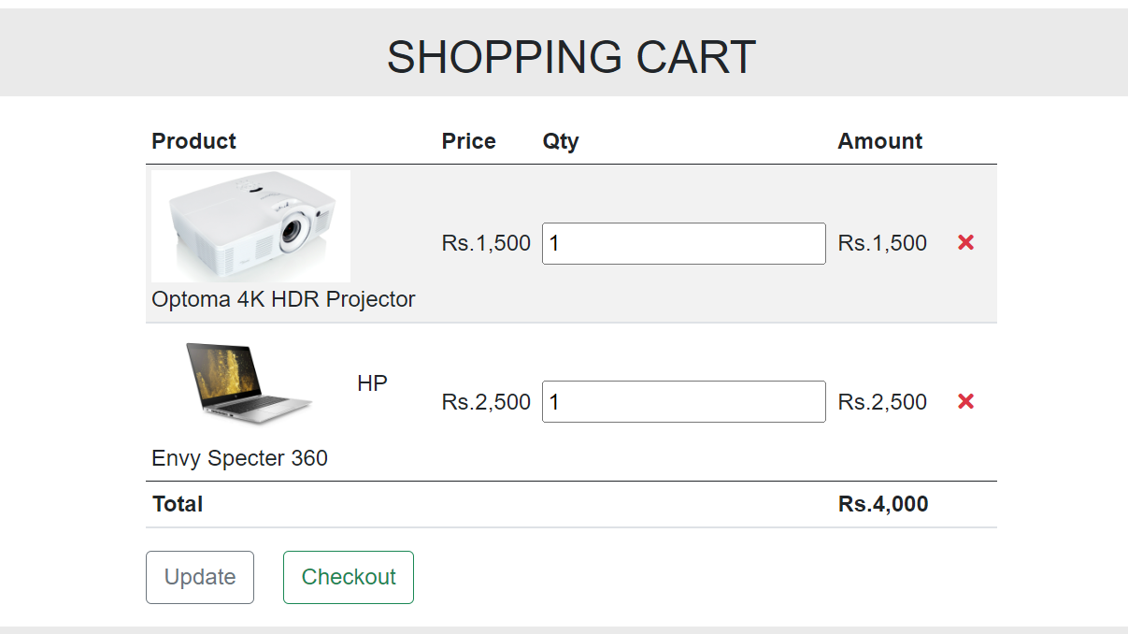

Figure 3 4: Shopping cart

# CHAPTER IV

# AN ASSESSMENT OF THE INTERNSHIP

## Learn from the Internship

The three months long internship program at Charicha Institute. was author’s first exposure in an IT company. The author had no any working experiences before in a real world scenario except of academic qualifications.

In those ten weeks, the author believes to have developed several interpersonal and professional skills that will have a huge impact in the forthcoming days.

1. **Work in a corporate Environment**

The internship program presented author with the opportunity to work in a real world working scenario and experience the workplace culture and tradition.

1. **Team Work and Collaboration**

Team work and collaboration is vital in context of an organization. The author experienced how a project is completed with the combined efforts of all the group members.

1. **Use Different Tools**

The internship presented author to work with different tools. The author used different tools for the frontend and backend development.

1. **Adopting New Skills**

Chances are interns are either paid or completely unpaid but author build skills that will be useful in your industry, and consider that capitalizing on your work.

1. **Professional Communications**

One of the most valuable skills author gained from an internship is the ability to speak with people in a professional setting. Discussions with bosses or co-workers are different from discussions with lecturers or fellow students.

## Applied Theory Knowledge into Practicum

As a student of BICTE, the author had studied various subjects related to Programming, as Web development, Databases, java etc. at college. Through this internship, the author got the opportunity to implement these theoretical skills of in my study, I have learned from frontend design by using html, CSS, JavaScript, Bootstrap, Git and implemented these tools in practical project. The theoretical knowledge has been practiced and executed in the real word scenarios which has given me more energy and raised my passion to further sharpen my knowledge.

## Challenges

In this 3 months period of internship, the author came across various challenges to face:

1. I had to learn setup of h/w and troubleshoot it and repair it from beginning, which was a new topic for me.
2. There were lot of problems on some pcs and troubleshooting them was the most tedious tasks.
3. I was feeling very pressure as I had to apply my practical knowledge in real field.

# CHAPTER V

# CONCLUSION

Internship has been an excellent and rewarding experience. Intern has been able to meet and network with so many people that surely will be able to help with opportunities in the future.

One main thing that have learn through this internship is time management skills as well as self-motivation. Working at Charicha Institute, I learned lots of new things and also engaged in development of support system. Being developing member it helped to gain knowledge in terms of technical field as well as non-technical field which I found equally important. I was for fortunate that the staffs at Charicha Institute were friendly, helpful which help to adjust in the environment.

# REFERENCES

1. https://www.w3schools.com/html/
2. https://www.w3.org/QA/Tips/Doctype
3. https://developer.mozilla.org/enUS/docs/Archive/Web/Properly_Using_CSS_and_JavaScript_in_XHTML_Document s_
4. https://edusanjal.com/course/bed-in-information-communication-technology-tribhuvan-university/
5. http://www.umsl.edu/~joshik/msis480/chapt05.htm
6. <https://getbootstrap.com/>
7. https://css-tricks.com/